Problem statement: Why it’s a useful question to answer and details about the client (get this from your proposal)

Online product review networks help to transmit information that customers can use to evaluate products in Internet commerce. These networks frequently include an explicit social component allowing consumers to view both how community members have rated individual product reviews and the social status of individual reviewers (Dhanasobhon, et al., 2007).

Digital networks for product information have redefined traditional “word-of-mouth” social networks by allowing consumers to easily share their opinions and experiences with other members of large-scale online communities (Dellarocas 2003). Many online retailers, such as Amazon.com and BarnesandNoble.com, are augmenting their product markets by building online communities to provide product reviews to other consumers. Likewise, many auction sites, such as Ebay.com, allow consumers to rate product sellers. Such information sharing has the potential to reduce the uncertainty consumers face regarding the quality of a product or a seller.

Several papers in the literature have shown that large-scale information sharing in digital networks may help communicate product/seller quality and build trust between buyers and sellers in online markets (Dhanasobhon, et al., 2007). There are many on-line settings in which users publicly express opinions (Danescu-Niculescu-Mizil et al., 2009). It’s easy to assume that while buying a product from an Amazon store, customers first checks the ratings of the products which are displayed as stars. When a more detailed user feedback is desired, the reviews are considered as a resource because reviews carry way more information than the ratings.

Resnick (2002) shows that seller reviews in eBay influence the probability of a sale, while Chevalier and Mayzlin (2006) find that product reviews at Amazon.com impact book sales. This raises the question of:

* What makes a review positive and what makes it negative?
* What is the common point of good reviews and bad reviews?

In this study, I will investigate what makes a review a good review and what makes it a bad review. In addition, by using Neural Language Processing (NLP), I developed a prediction model. The prediction model will tell whether the review indicates a positive rating or negative rating. In addition, the study will provide some explanation to misclassification.

Description of the dataset, how you obtained, cleaned, and wrangled it

The data used in this project was downloaded from Kaggle. It was uploaded on Kaggle by J. McAuley and J. Leskovec who are Kaggle.com users under the username of Stanford Network Analysis Project. This dataset consists of reviews of fine foods from amazon. The data span a period of more than 10 years, including all 568.454 reviews up to October 2012. Reviews include product and user information, ratings, and a plain text review.

**Data includes:**

* Reviews from Oct 1999 - Oct 2012
* 568,454 reviews
* 256,059 users
* 74,258 products

Table 1

*Column Names and Their Explanation*



|  |  |
| --- | --- |
| Feature | Explanation |
|  |  |
| Id | Row Id |
| ProductId | Unique identifier for the product |
| UserId | Unqiue identifier for the user |
| ProfileName | Profile name of the user |
| HelpfulnessNumerator | Number of users who found the review helpful |
|  | Number of users who indicated whether they found |
| HelpfulnessDenominator | the review helpful or not |
| Score | Rating between 1 and 5 |
| Time | Timestamp for the review |
| Summary | Brief summary of the review |
| Text | Text of the review |
|  |  |
| Total | 10 Rows |
|  |  |

Initial findings from exploratory analysis (data story and inferential statistics)

After the end of the topic modeling (Table 2), the prevailing topics are (1) pet items, and (2) beverages. As a result of the topic modeling, it can be seen that reviewers are complaining and praising for almost the same products because prevailing topics are the same for both good reviews and bad reviews.

Table 2

*Final Topic Modeling with Fine Tuned Parameters with Nouns Only*



Topic Modeling With 3 Topics



Topic 1:

'0.053*"coffee" + 0.025*"tea" + 0.020*"taste" + 0.019*"flavor" + 0.013*"cup" + 0.011*"chocolate" + 0.011*"water" + 0.011*"product" + 0.009*"price" + 0.008*"use"



Topic 2:

0.034*"food" + 0.016*"product" + 0.013*"dog" + 0.012*"cookies" + 0.010*"dogs" + 0.009*"treats" +

0.008*"price" + 0.008*"mix" + 0.008*"milk" + 0.007*"seeds"



Topic 3:

0.016*"flavor" + 0.014*"taste" + 0.014*"chips" + 0.013*"product" + 0.009*"price" + 0.008*"bag" +

0.008*"snack" + 0.007*"order" + 0.007*"store" + 0.007*"salt"

When we use ​*polarity​*and ​*Good Reviews* *​*features and create a plot, we get Figure 1.Figure 1 tells that subjectivity and polarity shows a funneling pattern to a certain degree. It can also be observed that low subjectivity scored reviews are also neutral reviews in terms of polarity.

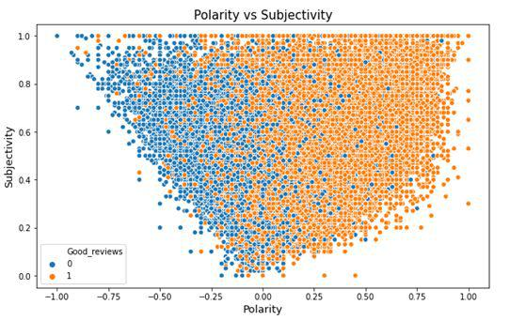

Figure 1: Subjectivity and polarity scores hued to good reviews category

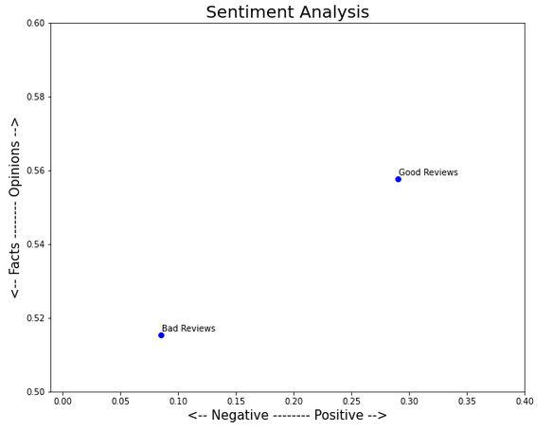

Figure 2: Mean value of polarity and subjectivity scores for review ratings

Figure 2 is a presentation of how polarity and subjectivity is affected by rating of the reviews (Good review feature). While reading this plot, we need to keep in mind that y-axis is in a very small range. Mean subjectivity score difference between two groups is negligible.

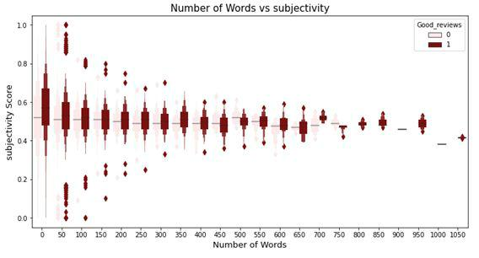

Figure 3: Number of Words and Subjectivity depending on Good Review Category

When we check the number of words and subjectivity (Fig. 3), it is hard to observe a relation between these two criteria. On the other hand, it can be observed that mean subjectivity score is slightly higher in positive reviews (Good reviews is 1).

**Helpfulness vs Polarity**​: Figure 4 presents the relation between​*helpfulness​*and​*polarity​*in theGood​*Reviews​*category. There are interesting outliers. For example, some reviews have lowest polarity (most negative) but good rating (good review is 1) and helpfulness is more than 3. This is an interesting combination. In Table 3, we can see that those reviews are not using negative words for the purchase. Those negative expressions are for comparison with other purchases. For now, NLP cannot handle this kind of contextual usage of words.

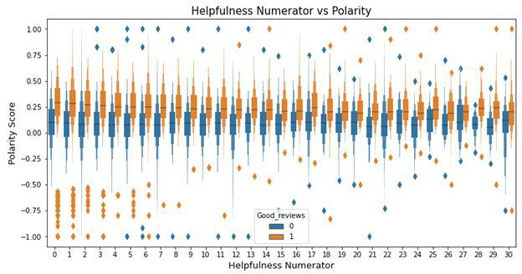

Figure 4:Helpfulness and Polarity in category of Good Reviews

Table 3

*Reviews that have polarity is -1 (most negative), helpfulness score is more than 3, and Good review is 1.*



Reviews



'brotherinlaw got hooked bariani olive oil terrificbr use almost every day like storebought brands almost gooey awful tasting recommend everyone well everyone wouldnt',

'forget highpriced energy tsps anything give energy youve ever imagined shocking',

'coffee greatthe price awful get thing bed bath beyond use one coupons',

'sf syrups taste awful one taste like expect bravo',

